8d,8e,8f 8.6.2020.
Hi everyone!
I hope you had a good rest over the weekend and you're ready to work.
1) Let's check the reported speech exercise from last time. Correct the mistakes if you have any.
Student's book at page 73, ex. 5a
2. Liz wants to know if Sunita wants to stay at her place on Friday after Lloyd's party. Liz's parents said it would be OK.
3. Bob wants to know what Kelly has done with the TV remote. He can't find it anywhere.
4. Jim wants to know whether his dad bought a new printer cartridge the other day. The printer's run out of ink and he needs to print something.
5. Beth's mum wants to know whether Beth needs a lift from dance class. Her dad will pick her up if she does.
6. Nick wants to know what time Pete can play table tennis on Saturday. He wants to book a table today if possible.

2) Now let's start your today's lesson. Look at this picture. It shows a very famous balcony. Do you know whose balcony it is? Where is it?
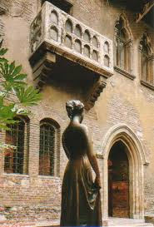
Open your Student's Book at pages 74-75 and find out.
Read the text at page 75 and listen to it on this link:
https://elt.oup.com/student/project/level5/unit06/audio_hr?cc=hr&selLanguage=hr (Page 74, Exercise 1)
Do exercises 1,2,3,4,5 in your book. (page 74)
Write the words from ex.5a in your notebooks together with their translation – you can find it in the dictionary in your Workbook, page 86
Usmeno odgovori na pitanja u zadatku 6.
That's all for today. Do the exercises, but don't send them.
Bye!
Teacher Marina

