6.def – 15. TJEDAN 2. SAT – THE EEEEEEND!
You've made it!
Congratulations!
Feel free to enjoy your summer – you've deserved it! Here are some ideas what to do during lazy summer days. I hope you'll find something that suits you.
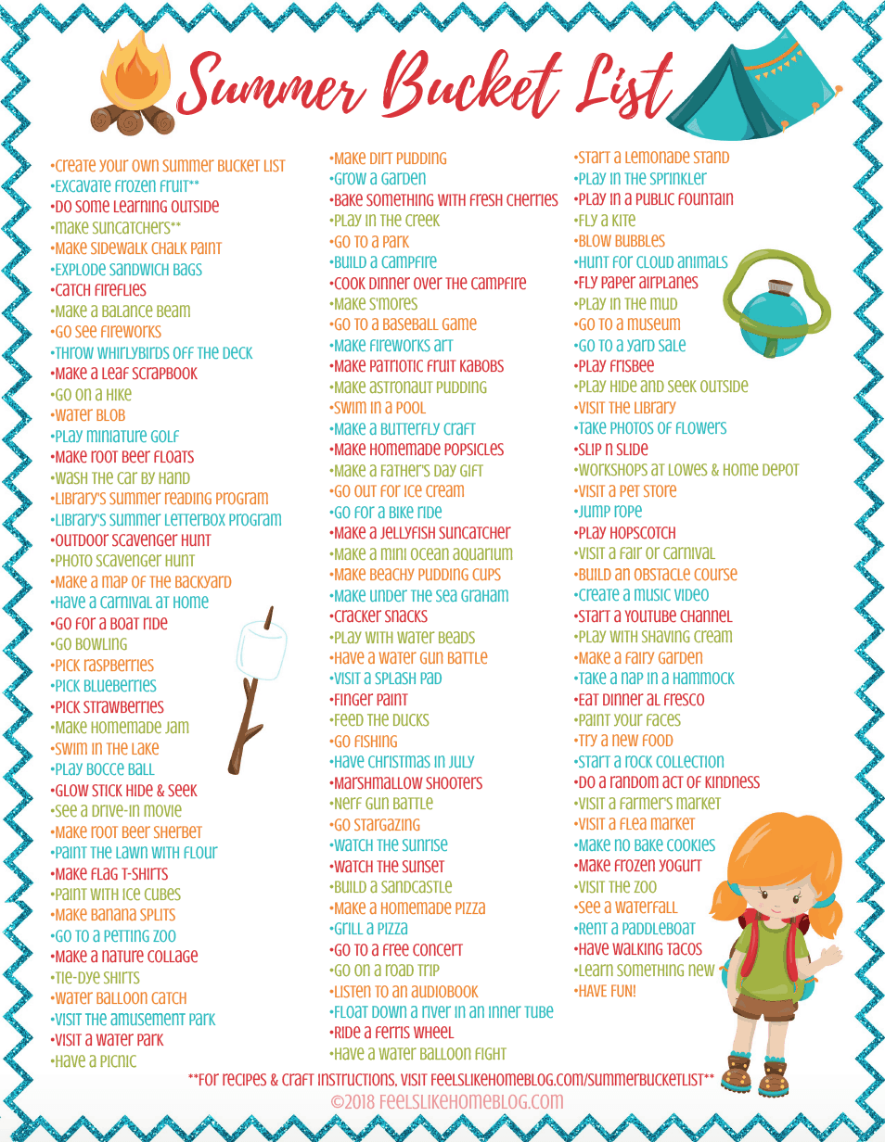
Stay healthy – keep distance – wash your hand! Teacher Tihana Š.

