Zadaća za 03.04. 2020.

- sat
Pozdrav svima,
Nadam se da ste dobro i da stižete izvršavati zadatke koje vam šaljemo.

Prvo ćemo malo ponoviti pravilo za brojive/nebrojive imenice
Većina ste jako dobro riješili zadatke pa ću vam samo napomenuti da NEBROJIVE IMENICE ne možemo brojiti kao ONE APPLE,TWO APPLES ... i nemaju nastavak za množinu –s ili –es.

Da biste to još jednom provježbali ,poigrajte se na slijedećem linku
countable,uncountable nouns - https://learningapps.org/watch?app=5158629
i upotreba some/any - https://learningapps.org/view2406917

Nadam se da ste bili uspješni u igrama pa sad možemo dalje.

Ishod : Nakon ove lekcije moći ćete izraziti količinu neke namirnice uz pomoć ovih izraza i napisati listu za kupovinu

Ovu tablicu imate u udžbeniku na stranici 62
To su izrazi za količinu za nebrojive imenice. Prouči ovu tablicu:

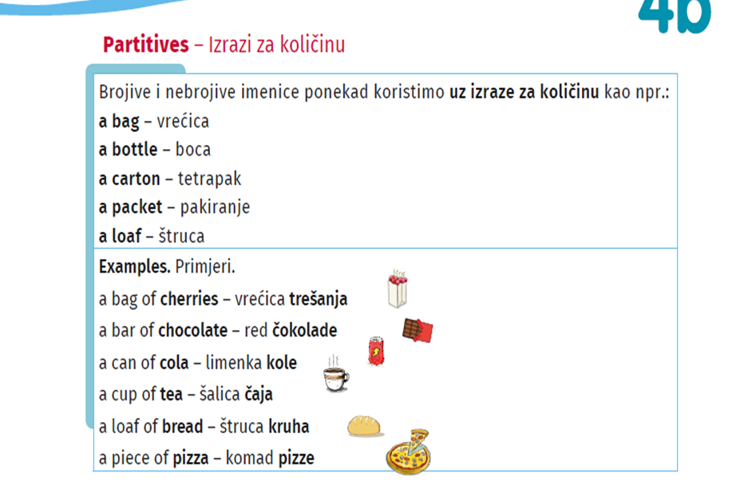

Task 1
Look at your fridge and describe 6-7 items you've got there.
Use the partitives to express quantity:
(Pogledaj u svoj frižider i opiši 6-7 namirnica koje su tamo.Koristi izraze za količinu.)

Example: a bowl of .... (zdjela ...)
a carton of .... (tetrapak ...)

Write the list and upload it to Teams .
(napiši listu namirnica i stavi u Teams)

My fridge :
1.
2.
3.

Task 2
Ask your mum/dad what she needs in the shop
and make a shopping list :
Choose at least 6 partitives .
Write the shopping list and upload it to Teams
( Pitaj mamu/tatu što treba iz trgovine i napravi listu za kupovinu.Izaberi najmanje 6 izraza iz tablice. Napiši listu u bilježnicu i postavi u Teams.)

Use these partitives :
a kilo of a slice of a loaf of can of

a carton of a bottle of a packet of a bag of

My shopping list
1.
2.
3.

Ova dva zadatka riješite u bilježnicu i pošaljite na Teams.
Za vježbu riješi u RB zadatak 1 na strani 103.

- sat
I've got the news for you:
Radio Samobor reported that we will get a zoo in Vugrinščak Park.

Can you believe it???? It April Fool's Day !!!!!

It's a very popular in many countries .
People like to trick their friends and family.
These jokes are called hoaxes (obmane) and pranks („neslane“ šale)
FAMOUS HOAXES
- In 1957 the best hoax ever was :

Spaghetty grow on a tree in Switzerland because of the warm winter.

A lefthaned toilet paper was invented
(izumljen je toaletni papir za ljevake)
Task 1

Your task is to create a hoax or any kind of a joke and upload it on Teams
(Tvoj zadatak je da napišeš neku obmanu ili bilo kakovu šalu i pošalješ u Teams)

- sat

Ishod :Nakon ove lekcije moći ćete pitati koliko ima nečega i izraziti količinu nečega

Copy this chart: ( Prepiši ovu tablicu)

COUNTABLE NOUNS | UNCOUNTABLE NOUNS
How many....? | How much.....?
There are too many cars.  There are a lot of/lots of cars.  There are some /a few cars.  There are few/not many cars. | There is too much sugar in my coffee.  There is a lot of /lots of sugar...  There is some /a little sugar...  There is little/not much sugar...

Task 1

Describe this picture (Opiši ovu sliku ):

Use A LOT OF/A FEW / A LITTLE

1-THERE IS ……………….COKE.
2-THERE IS ……………….LETTUCE.
3-THERE ARE ……………CHIPS.
4-THERE IS ……………….CHEESE.
5-THERE ARE ……………..SLICES OF TOMATOES.
6. THERE IS........ FOOD ON THE PLATE.

Copy this task and upload it on Teams .(Prepiši ovaj zadatak i pošalji u Teams.)

Za vježbu riješi zadatke u radnoj bilježnici na strani 32.
To ne moraš slati u Teams.

