Animals

1 Write the correct animal.
Upiši točan naziv životinje.
1 There aren’t many ____________ 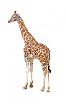in the world.
2 A ____________ is dangerous.
3 My grandma has lots of ____________ 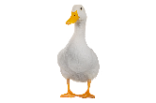
4 I am afraid of ____________ 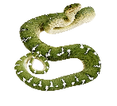.
5 A ____________ 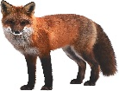is a very clever animal.
6 An ____________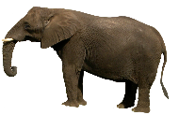 is the biggest land animal.
7 A ____________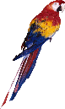 can talk.

2 Read the animal body parts.
Pročitaj dijelove tijela životinja.
back – leđa
beak – kljun
ears – uši
eyes – oči
fur – krzno
head – glava
leg – noga
mane – griva
neck – vrat
nose - nos
tail – rep
trunk – surla
wing – krilo

3 Label the parts.
Upiši točne nazive dijelova tijela.

THAT'S IT FOR TODAY.

HAVE A NICE DAY!

Key:

