(ako nemaš printer, onda samo napiši odgovore u bilježnicu)
1 Find the jobs. Complete the crossword. Use the words from Task 1.
Pronađi zanimanja. Riješi križaljku. Upotrijebi nazive iz 1. zadatka.
1 acts in theatre or in films
2 paints portraits
3 sings in a band
4 writes stories
5 expert in physics
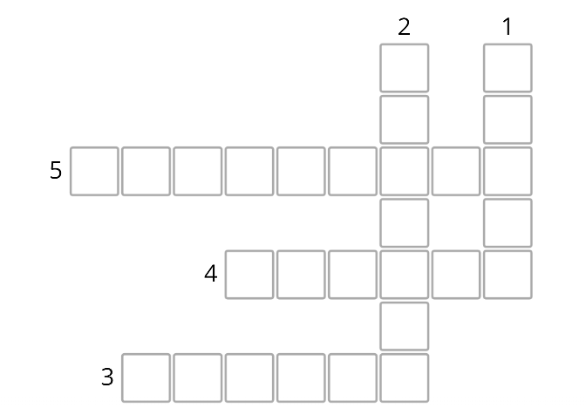

2 Complete the gaps with the missing words: trains, actor, ships, writer, motorcycle, planes.
Dopuni tekst riječima: trains, actor, ships, writer, motorcycle, planes.

Paul is an ________________ 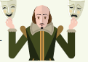.
He lives in London.
His brother, Andy, is a _________________.

He lives in Beaconsfield.

This town is famous for Bekonscot Model Village.

One special feature of Bekonscot is a model railway track.
Twelve _____________ can go around the track.
There is also a small fishing village with _______________ in
the harbour and an airport with model _______________ 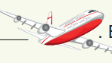.
Bekonscot Model Village is one hour by car from London.
Paul often goes to see his brother on his _______________..

