**Module 6 Lesson 1**

**Famous people**

**1 – Famous people and their jobs**

**A lot of famous people have one of these jobs. Match the jobs and translation.**

Mnoge poznate osobe imaju ova zanimanja. Spoji zanimanja i prijevod.

**a writer** kraljica

**a singer** fizičar

**a painter** pjevač

**a physicist** slikar

**Queen** pisac

**2 – Here are some famous persons. Can you guess their jobs?**

Ovdje su neke poznate osobe. Možeš li pogoditi njihova zanimanja?

  

Elizabeth I Vincen van Gogh Charlie Chaplin

_________________________________________________________

  

Charles Dickens Elvis Presley Albert Einstein

____________________________________________________________________

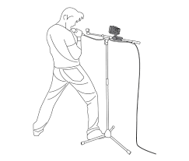**3 - Label the pictures.** Napiši zanimanja.



a w__________________ a s_____________

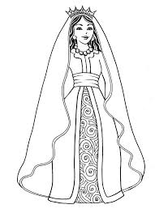 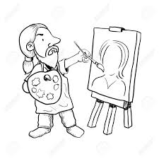

a p_______________________ a q_______________

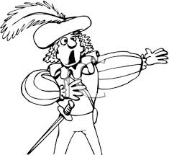

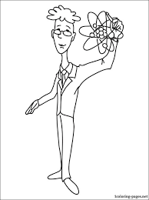

a p_______________________ an a________________

**THAT'S IT FOR TODAY.**

**HAVE A NICE DAY!**

