Vocabulary practice

1 Match jobs 1–8 with pictures A–H.
Spoji zanimanja sa slikama.
- pilot _____  - engineer _______  - lorry driver _______  - electrician _______  - vet _______  - cleaner ________  - architect _______  - builder ________ |  | - 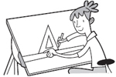  - 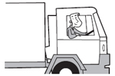
2. Complete the sentences.
Dopuni rečenice zanimanjima.
  - A c__________ cooks food in a restaurant.
  - An a__________ designs buildings.
  - An e__________ works with electrical things.
  - An e__________ builds roads and bridges.
  - A v__________ looks after sick animals.
  - A f_______ a_______ looks after passengers on a plane.
  - A n__________ takes care of sick people.
  - A s__________ writes and answers letters and emails in an office.

